EX1:
#define _CRT_SECURE_NO_WARNINGS
#include <stdio.h>
int main() {
float arr1[2][2];
float arr2[2][2];
float sum[2][2];
printf("Enter the elements of 1st matrix\n");
for (int i = 0; i < 2; i++)
for (int j = 0; j < 2; j++)
{
printf("Enter a%d%d:", i+1, j+1);
scanf("%f",&arr1[i][j]);
}
printf("Enter the elements of 2st matrix\n");
for (int i = 0; i < 2; i++)
for (int j = 0; j < 2; j++)
{
printf("Enter b%d%d:", i + 1, j + 1);
scanf("%f",&arr2[i][j]);
}
for (int i = 0; i < 2; i++)
for (int j = 0; j < 2; j++)
sum[i][j] = arr1[i][j] + arr2[i][j];
printf("Sum Of Matrix:\n");
for (int i = 0; i < 2; i++)
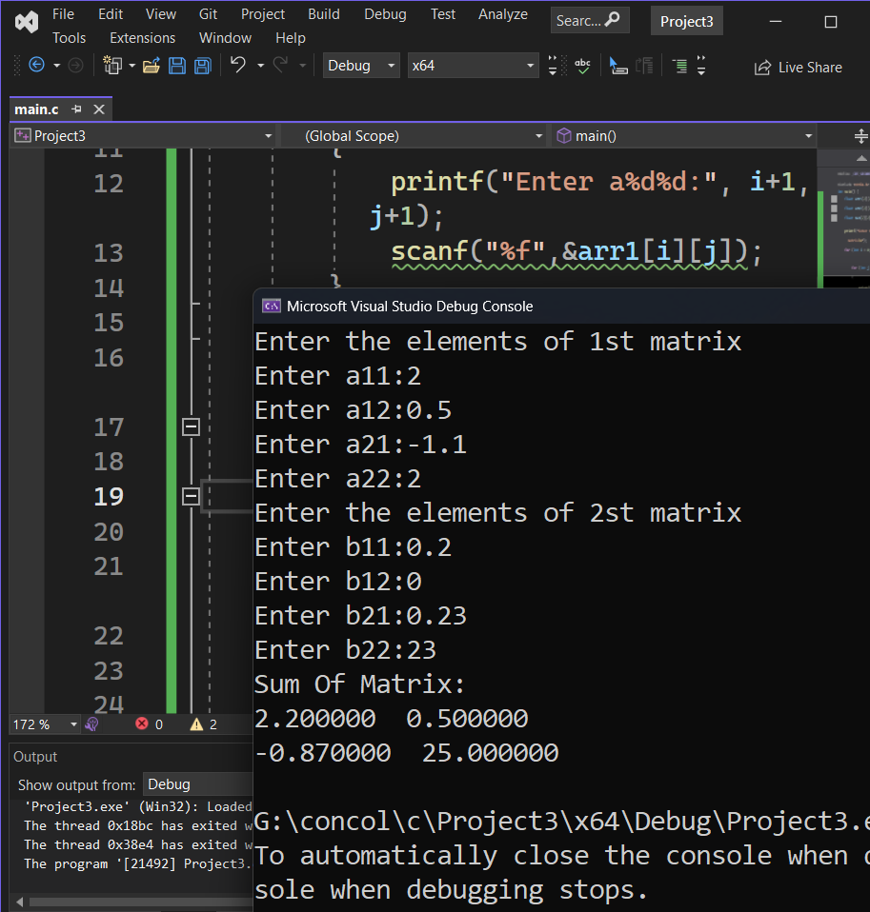
{
for (int j = 0; j < 2; j++)
{
printf("%f ", sum[i][j]);
}
printf("\n");
}
return 0;
}

Ex2:
#define _CRT_SECURE_NO_WARNINGS
#include <stdio.h>
int main() {
float arr1[200];int data;float sum=0;
printf("Enter the numbers of data: ");
scanf("%d", &data);
for (int i = 0; i < data; i++)
{
printf("Enter number:");
scanf("%f", &arr1[i]);
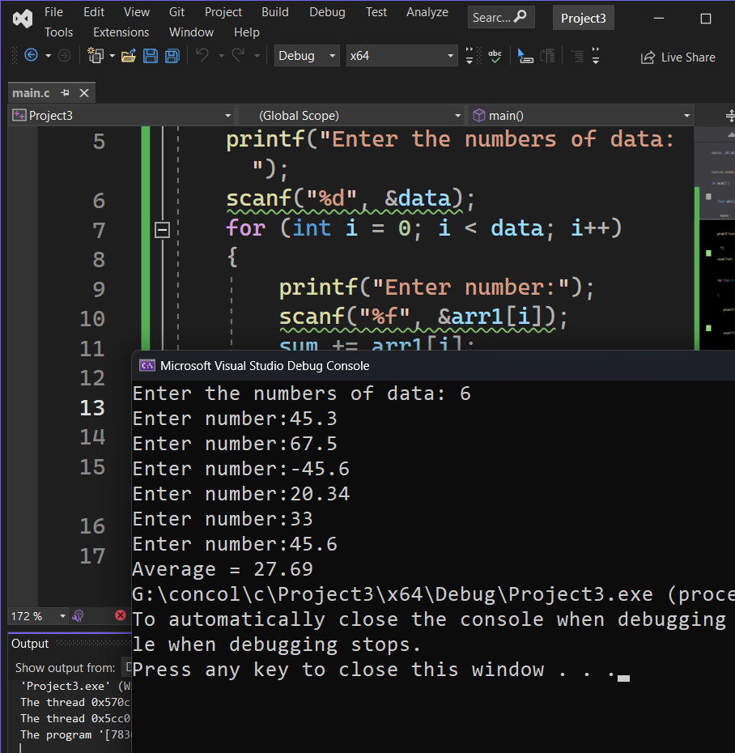
sum += arr1[i];
}

printf("Average = %.2f", sum / data);
return 0;
}
Ex3:
#define _CRT_SECURE_NO_WARNINGS
#include <stdio.h>

int main() {
int rows, cols;
printf("Enter rows and column of matrix: ");
scanf("%d", &rows);
scanf("%d", &cols);

float matrix[10][10], transpose[10][10];

printf("Enter the elements of the matrix:\n");
for (int i = 0;i < rows;i++)
for (int j = 0;j < cols;j++)
{
printf("Enter elements a%d%d:", i+1, j+1);
scanf("%f", &matrix[i][j]);
}
printf("\nEntered matrix:\n");
for (int i = 0;i < rows;i++) {
for (int j = 0;j < cols;j++)
printf("%.2f ", matrix[i][j]);
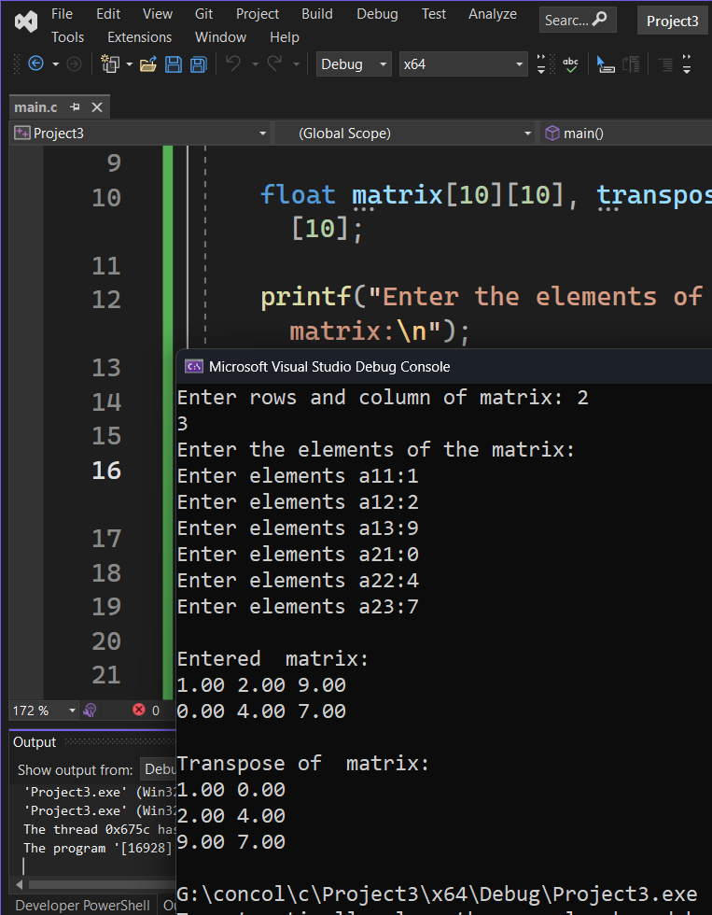
printf("\n");
}

for (int i = 0;i < rows;i++)
for (int j = 0;j < cols;j++)
transpose[j][i] = matrix[i][j];

printf("\nTranspose of matrix:\n");
for (int i = 0;i < cols;i++) {
for (int j = 0;j < rows;j++)
printf("%.2f ", transpose[i][j]);
printf("\n");
}

return 0;
}
Ex4:
#define _CRT_SECURE_NO_WARNINGS
#include <stdio.h>

int main() {
int n, pos;
int arr[100], newElement;

printf("Enter no of elements: ");
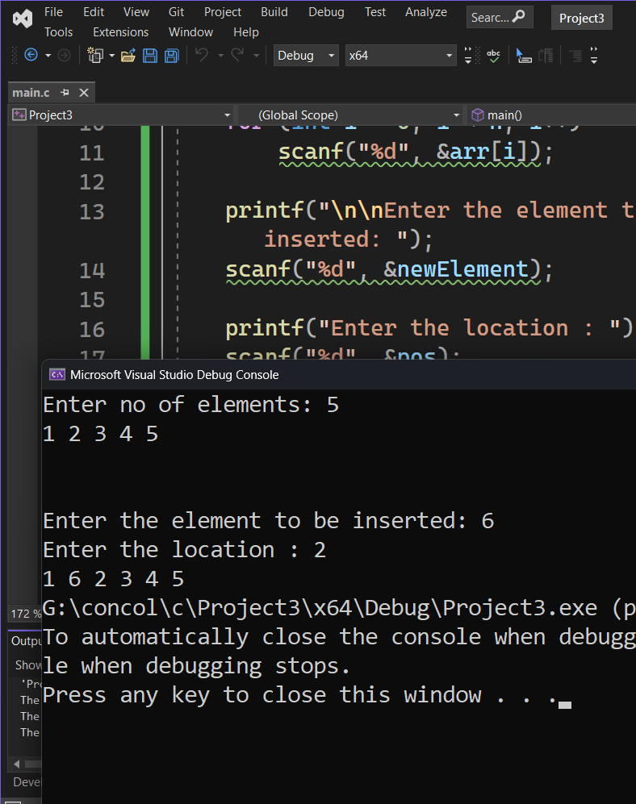
scanf("%d", &n);
for (int i = 0; i < n; i++)
scanf("%d", &arr[i]);

printf("\n\nEnter the element to be inserted: ");
scanf("%d", &newElement);

printf("Enter the location : ");
scanf("%d", &pos);

for (int i = n; i >=pos; i--)
arr[i] = arr[i - 1];

arr[pos-1] = newElement;
n++;

for (int i = 0; i < n; i++)
printf("%d ", arr[i]);

return 0;
}

Ex5
#define _CRT_SECURE_NO_WARNINGS
#include <stdio.h>
int main() {
int n, key, found = 0;
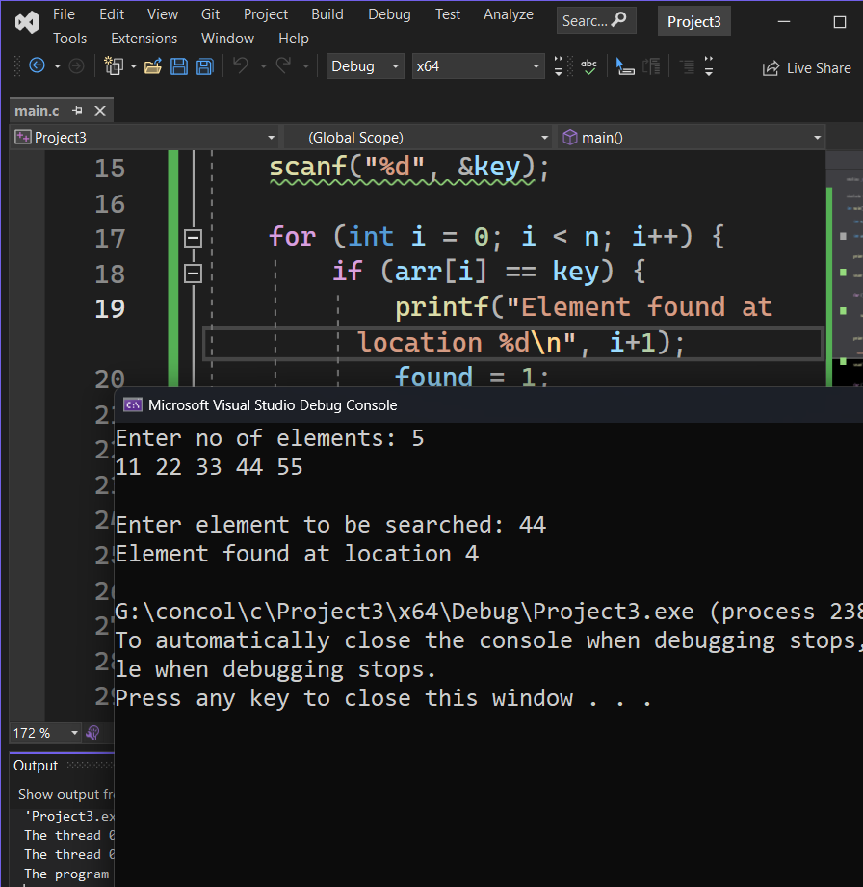
int arr[100];
printf("Enter no of elements: ");
scanf("%d", &n);
for (int i = 0; i < n; i++)
scanf("%d", &arr[i]);
printf("\nEnter element to be searched: ");
scanf("%d", &key);
for (int i = 0; i < n; i++) {
if (arr[i] == key) {
printf("Element found at location %d\n", i+1);
found = 1;
break;
}
}
if (!found)
printf("Element not found\n");
return 0;
}

HW string
Ex1:
#define _CRT_SECURE_NO_WARNINGS
#include <stdio.h>

int main() {
char str[100];
char ch;
int count = 0;

printf("Enter a string: ");
fgets(str, sizeof(str), stdin);
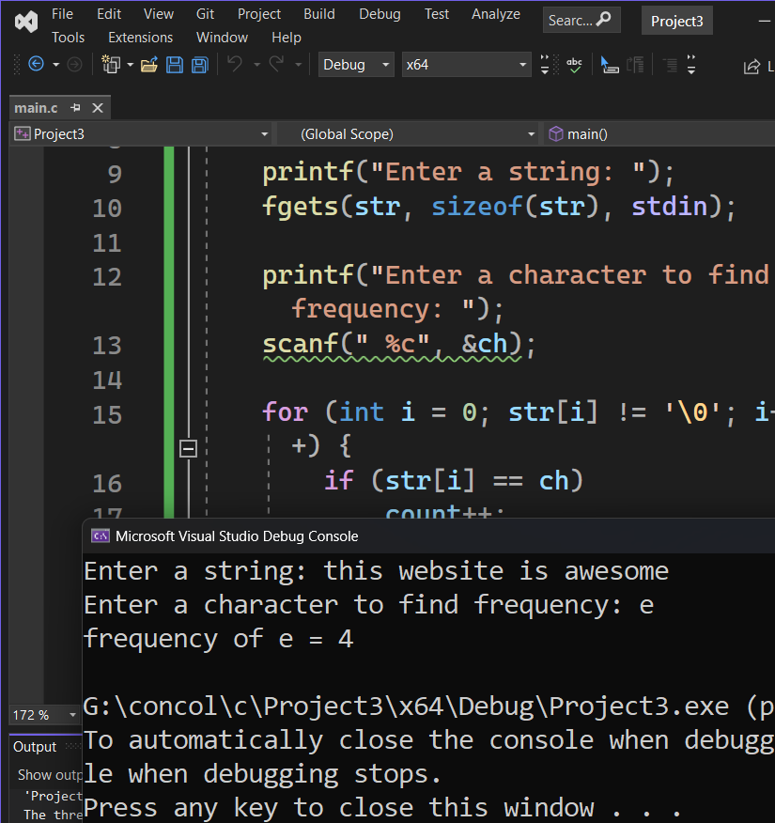
printf("Enter a character to find frequency: ");
scanf(" %c", &ch);

for (int i = 0; str[i] != '\0'; i++) {
if (str[i] == ch)
count++;
}

printf("frequency of %c = %d \n", ch, count);

return 0;
}

Ex2:
#define _CRT_SECURE_NO_WARNINGS
#include <stdio.h>

int main() {
char str[100];
int count = 0;
printf("Enter a string: ");
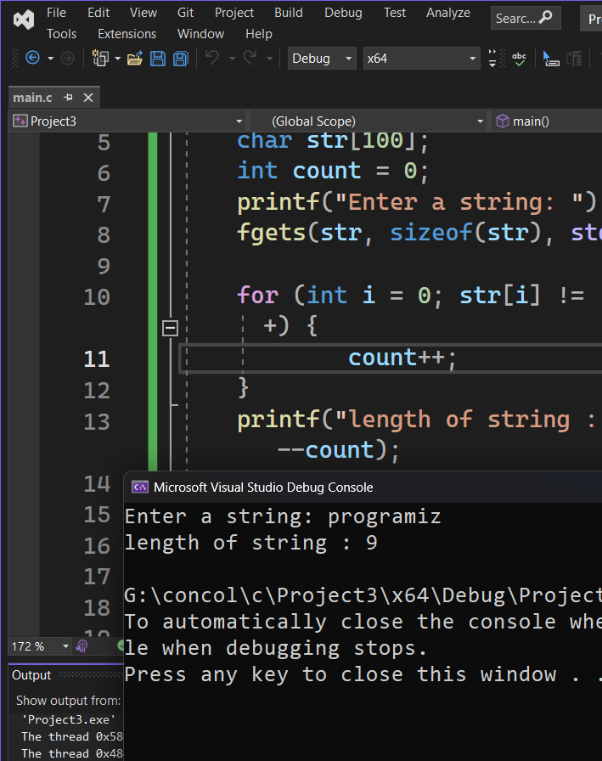
fgets(str, sizeof(str), stdin);

for (int i = 0; str[i] != '\0'; i++) {
count++;
}
printf("length of string : %d \n", --count);

return 0;
}

Ex3:
#define _CRT_SECURE_NO_WARNINGS
#include <stdio.h>
#include<string.h>
int main() {
char str[100];
char rev[100];
int count = 0;
printf("Enter the string : ");
fgets(str, sizeof(str), stdin);
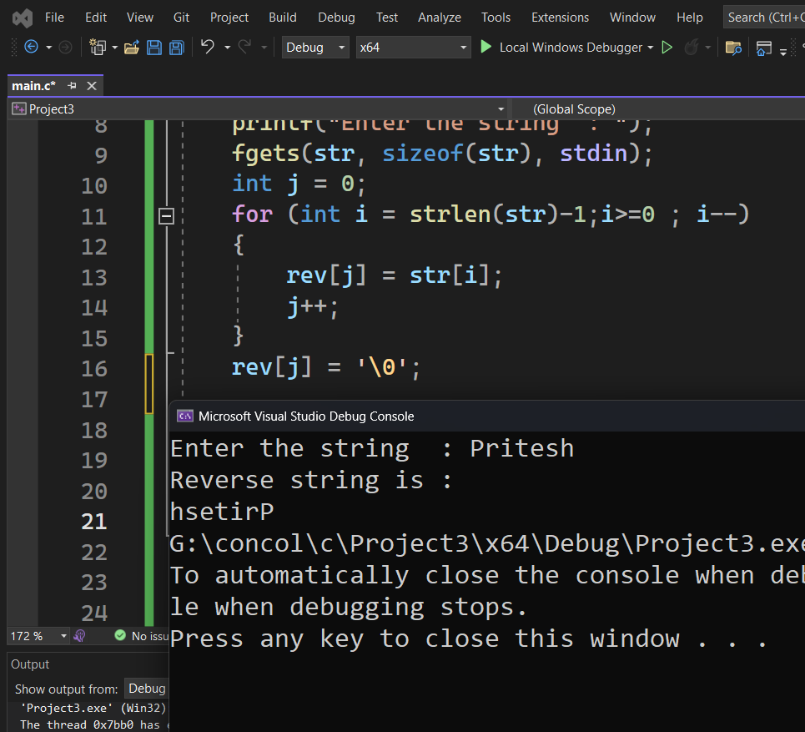
int j = 0;
for (int i = strlen(str)-1;i>=0 ; i--)
{
rev[j] = str[i];
j++;
}
rev[j] = '\0';
printf("Reverse string is : %s", rev);

return 0;
}

